You dared us to go dairyless — and we did! Ben & Jerry’s Non-Dairy flavor creations are made with almond milk & so boldly loaded with chunks & swirls that you’ll get Ben & Jerry’s euphoria in every bite
ShareTweetPin

Made with Almond Milk!
Why Almond Milk? After experimenting with all sorts of different formulas, our Flavor Gurus decided that almond milk provided the best “blank canvas” for the delicious brownies, caramel, nuts, and chocolate we sourced. And it’s so rich & creamy that while digging into a pint you will constantly have to remind yourself that it’s non-dairy.
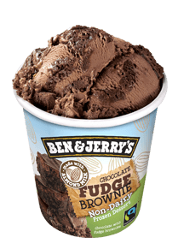
New!

Chocolate Fudge Brownie Non-Dairy

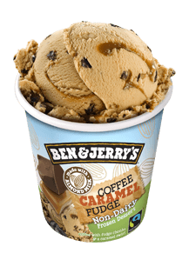
New!

Coffee Caramel Fudge Non-Dairy

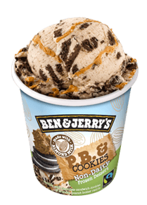
New!

P.B. & Cookies Non-Dair

